EXP 11
Aim
To perform affine transformation on an image using OpenCV.
Procedure
- Import OpenCV and NumPy.
- Read the input image.
- Select three source and destination points.
- Compute the affine transformation matrix.
Code
import cv2
import numpy as np
img = cv2.imread("image1.png")
rows, cols = img.shape[:2]
pts1 = np.float32([[50,50],[200,50],[50,200]])
pts2 = np.float32([[10,100],[200,50],[100,250]])
M = cv2.getAffineTransform(pts1, pts2)
result = cv2.warpAffine(img, M, (cols, rows))
cv2.imshow("Original", img)
cv2.imshow("Affine Transformation", result)
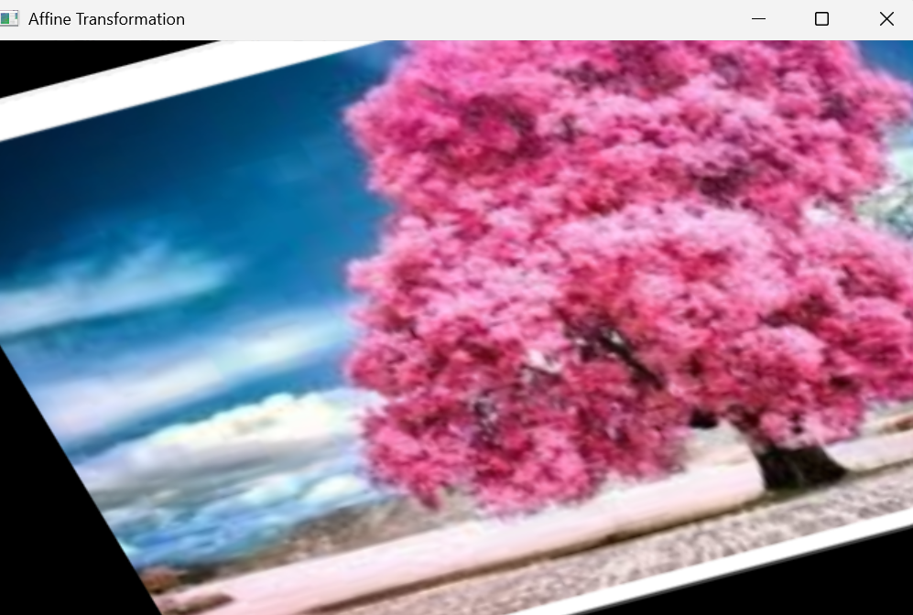
cv2.waitKey(0)
cv2.destroyAllWindows()
